Impact of Early Childhood Malnutrition on Cognitive Development and Academic Performance: A Longitudinal Study
1st Rishab Pillai
Hiranandani foundation school,
Mumbai, India
Rishabpillai09@gmail.com
2nd Vinay Vishwakarma
Mentor, On My Own Technology Pvt. Ltd
Mumbai, India
vinay.vishwakarma@omotec.in

Abstract—The cognitive and academic performance of children affected by malnutrition in early childhood is asserted to be harmed. This document provides an overview of NutriMind, a mobile application built for IOS and Android and developed using React Native that allows parents and educators to track a child's nutrition and cognitive development. The mobile application allows both parents and educators to record their child's daily food intake and monitor the diversity of nutrients they consume, track the progress of cognitive milestones, and engage the child in brain-training games. The system also provides notifications regarding the presence of nutritional risk patterns in a child's diet and allows for tracking the correlation between a child's dietary habits and his/her success at school, using the schools' integrated tracking features. The prototype implementation of the mobile application demonstrates that it is possible to combine nutritional and cognitive data for the purpose of detecting developmental delays early in a child's life.
Keywords—Early childhood nutrition, cognitive development, mobile health, academic performance, nutrition tracking, brain training, child development monitoring
- Introduction
Malnutrition in early childhood represents a major public health issue, affecting approximately 149 million children worldwide. The first five years of life provide the most critical period of development for cognitive skills, such as memory, attention span, problem solving, and learning ability. Studies show that children suffering from poor nutrition tend to perform lower on IQ tests, experience more failures in school, and have lower long-term economic productivity than children who are adequately nourished.
Currently, monitoring children's nutritional intake relies largely on periodic clinical visits and school-based programs. Many times, this means that children receive very little regular feedback and support around their nutritional intake. Mobile health technology offers an opportunity to address this by allowing for daily nutritional tracking and cognitive development assessments to occur outside of a clinical setting.
The NutriMind app is a complete mobile platform that integrates nutritional science and cognitive development

research with standardized assessments and other interactive tools to support the continuous monitoring of both nutritional intake and cognitive development milestones. The four major goals of the app are: 1) to improve caregivers' and educators' ability to continuously monitor children's nutritional intake and dietary diversity; 2) to improve caregiver and educator knowledge about cognitive development milestones; 3) to provide caregivers and educators with actionable alerts when children are at risk for poor nutrition; and 4) to identify patterns between children's dietary intake and academic performance.
The purpose of this paper is to describe the design, implementation, and validation of NutriMind, demonstrating how mobile technology can facilitate evidence-based child health and education interventions.

Literature Review
Early Childhood Malnutrition and Cognitive Development
According to Grantham-McGregor et al. (2007), malnutrition during the first 2 years of life can cause long-lasting cognitive deficits that will persist throughout adulthood; children who were malnourished during this early stage in life display average IQ scores that are 5 to 11 points lower than normal and have lower levels of academic achievement [4] due to impaired myelination, reduced neurotransmitter synthesis, and reduced synaptic plasticity in the developing brain [5].

Micronutrient Deficiencies and Brain Function
Globally, approximately 1.62 billion people suffer from iron deficiency anemia; this micronutrient deficiency significantly affects the cognitive development of children under the age of five [6]. Iron is an essential cofactor in myelin formation and mitochondrial respiration; lack of it leads to delays in motor development, a lack of focus, and reduced performance in the classroom [7]. Iodine deficiency also affects intellectual performance; it can result in intellectual disabilities and slower cognitive processing during fetal and early childhood periods, resulting in an estimated 15 million cases of preventable intellectual disability each year according to the World Health Organization, due to iodine deficiency [8].
Zinc deficiency also affects the structure of the hippocampus and synaptic transmission, and thus, has a direct impact on memory consolidation and learning [9]. The bioavailability of micronutrients is impacted by many variables, including food sources and dietary composition, so comprehensive nutritional assessments must be conducted rather than evaluating single nutrients [10].
Research has shown that use of fortified foods and supplementation by individuals who are malnourished increases raw cognitive performance by 0.2-0.4 standard deviations [11]. Programs that provide children with meals with protein and micronutrients have been demonstrated to lead to increased school attendance of 5-15 percent and improved academic performance of 0.3-0.5 grade levels [12].
Mobile health (mHealth) apps are effective tools to change health behaviors and improve health outcomes in the pediatric population. According to a systematic review completed by Hoque and Sorwar (2017), health-tracking mobile apps improve user engagement with the application and increase health knowledge. Increasing the number of users who engage with the application and experience an improved health outcome is especially successful if the application features elements of gamification [13].
The Food-Brain Connection (formerly developed by the North American Nutrition and Development Initiative) is based on the premise that in order for comprehensive monitoring of a child's development, nutritional status should be assessed concurrently with neurocognitive function [14]. It has been shown through research that early diagnosis and intervention for children experiencing a combination of nutritional and developmental delays yield better results than late intervention of a single domain of delay [15].

METHODOLOGY
- Application Architecture and Development
NutriMind is built using the React Native framework to allow it to be deployed across iOS and Android devices at once. The application has 3 layers of architecture: (1) The user interface layer uses Material Design, (2) The business logic layer performs the processing of data and the implementation of algorithms, and (3) The Data persistence layer stores the data securely using HIPAA-compliant encryption protocols in the cloud.

- User Interface and Features
- School Performance Module:
Figure 1 shows the School Performance Dashboard which provides an overview of academic performance through tracking of three scores - Mathematics, English, Science that range from 0 to 100. The dashboard also tracks behavioural metrics (Focus in Class, Social Skills) which are divided into Good, OK, Low categories, and includes notes from teachers regarding any academic deficiencies.
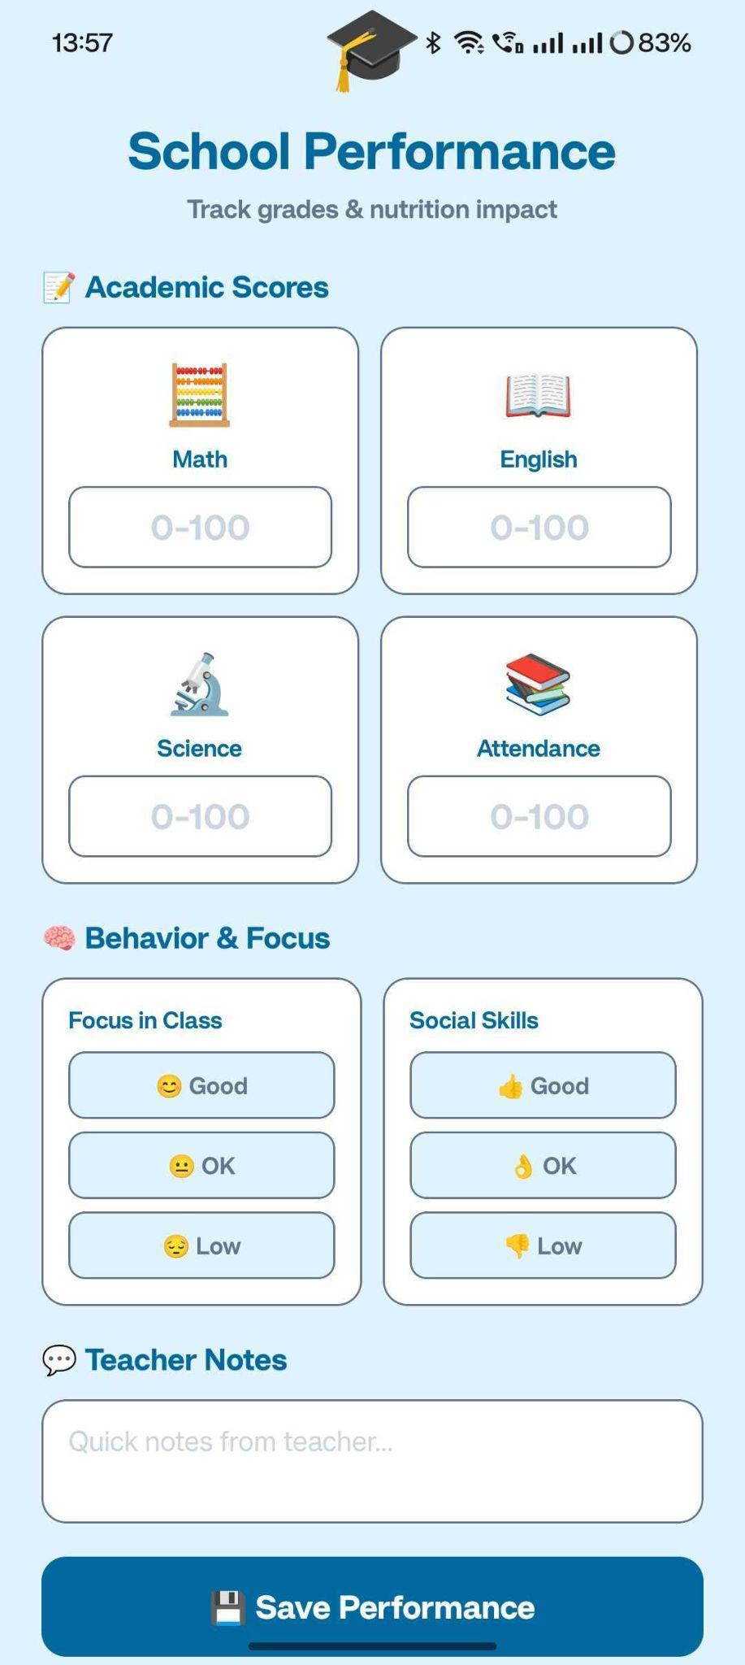
Figure 1: School Performance Module

- Memory and Cognitive Training
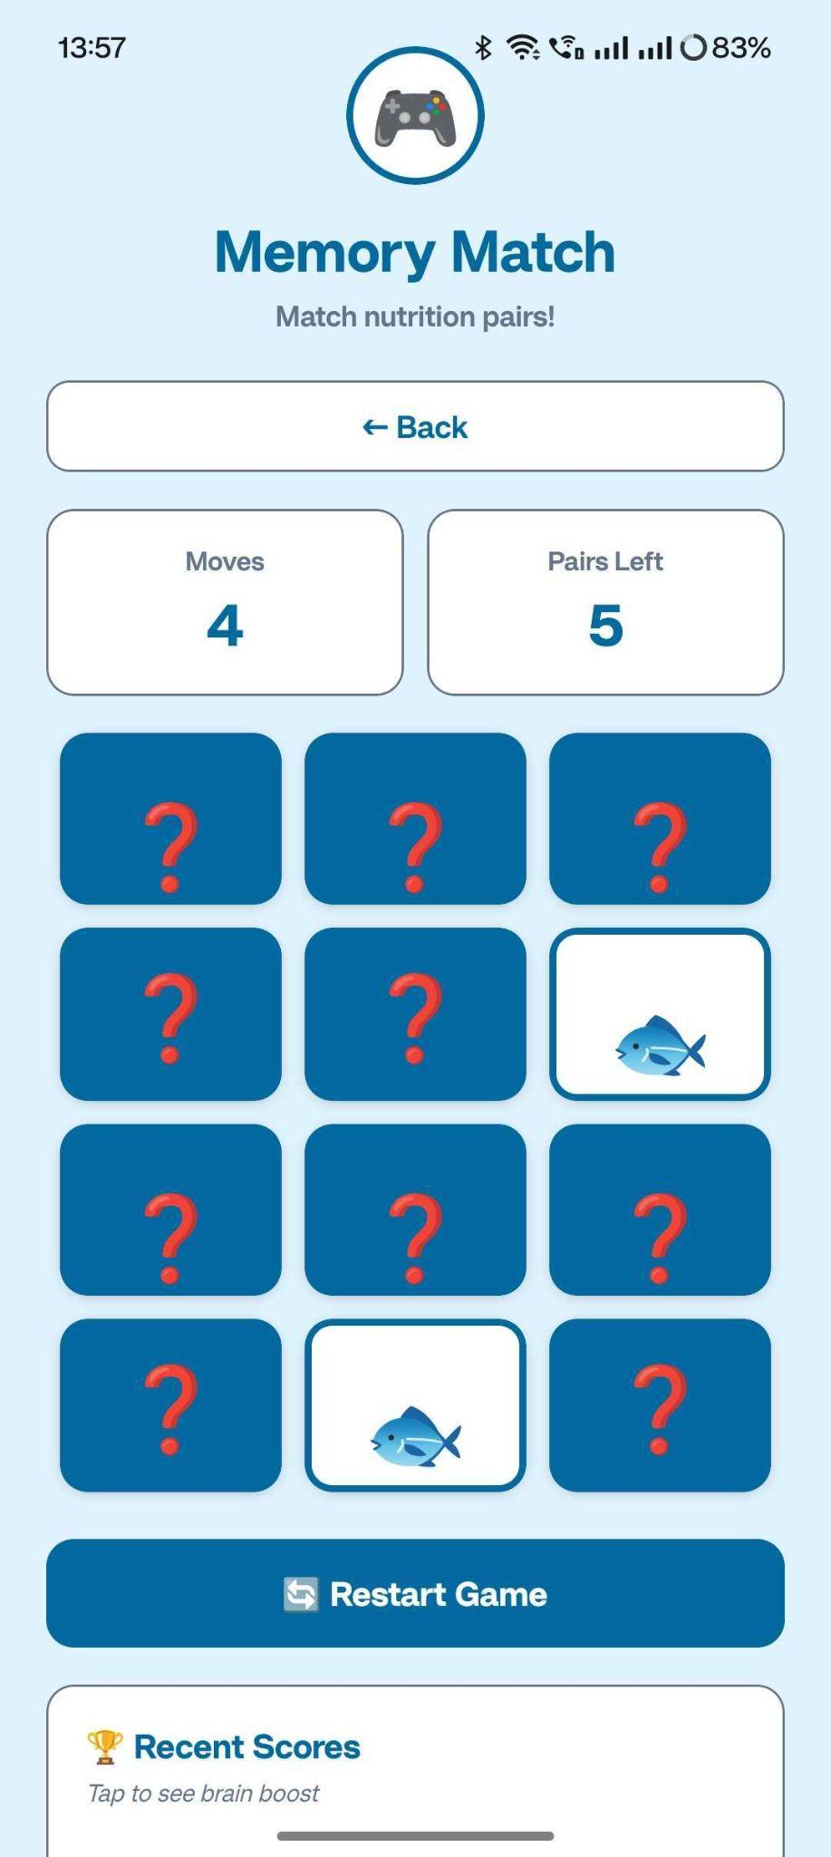
Figure 2: Memory Match Module
Figure 2 displays the Memory Match Game. This cognitive training module is designed to improve nutrition-related cognitive functioning through the use of a 4x3 grid matching food-related images. The Memory Match Game interface shows the number of moves made and how many pairs are left to match, demonstrating the use of gamification in cognitive training with the ability to track performance and replay.

- Nutritional Chemistry Education

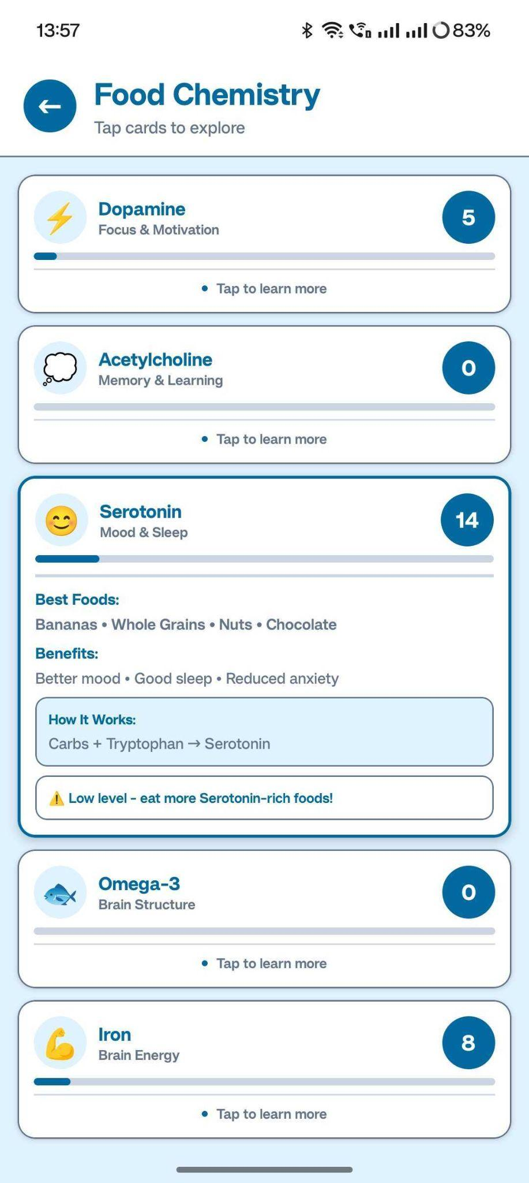
Figure 3: Nutrition Chemistry Module
Figure 3 illustrates the Food Chemistry module which is designed to help educate the user on the relationship between nutrients and neurotransmitters. The Food Chemistry Module interface uses five nutrients - Dopamine, Acetylcholine, Serotonin, Omega-3, Iron - and provides an explanation of each nutrients function in the body and where they can be found in food and their bioavailability, demonstrating the integration of cognitive development education with nutritional science.
- Food Logging Interface:
The main interface for the Food Logger as illustrated in Figure 4 includes meal time selections for breakfast, lunch, dinner, or snack, and a complete food category database including grains, proteins, vegetables, fruits and legumes that provide a means for detailed tracking of dietary habits and nutrient composition analysis .

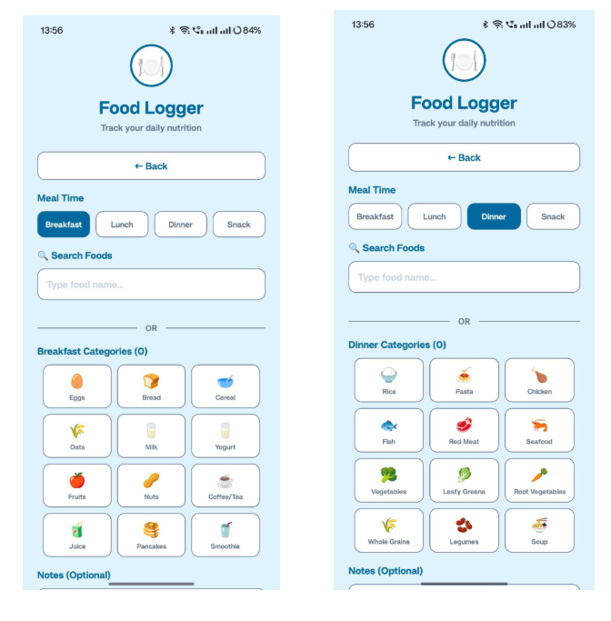
Figure 4: Food Logging Interface

- Meal Breakdown and Nutrient Analysis
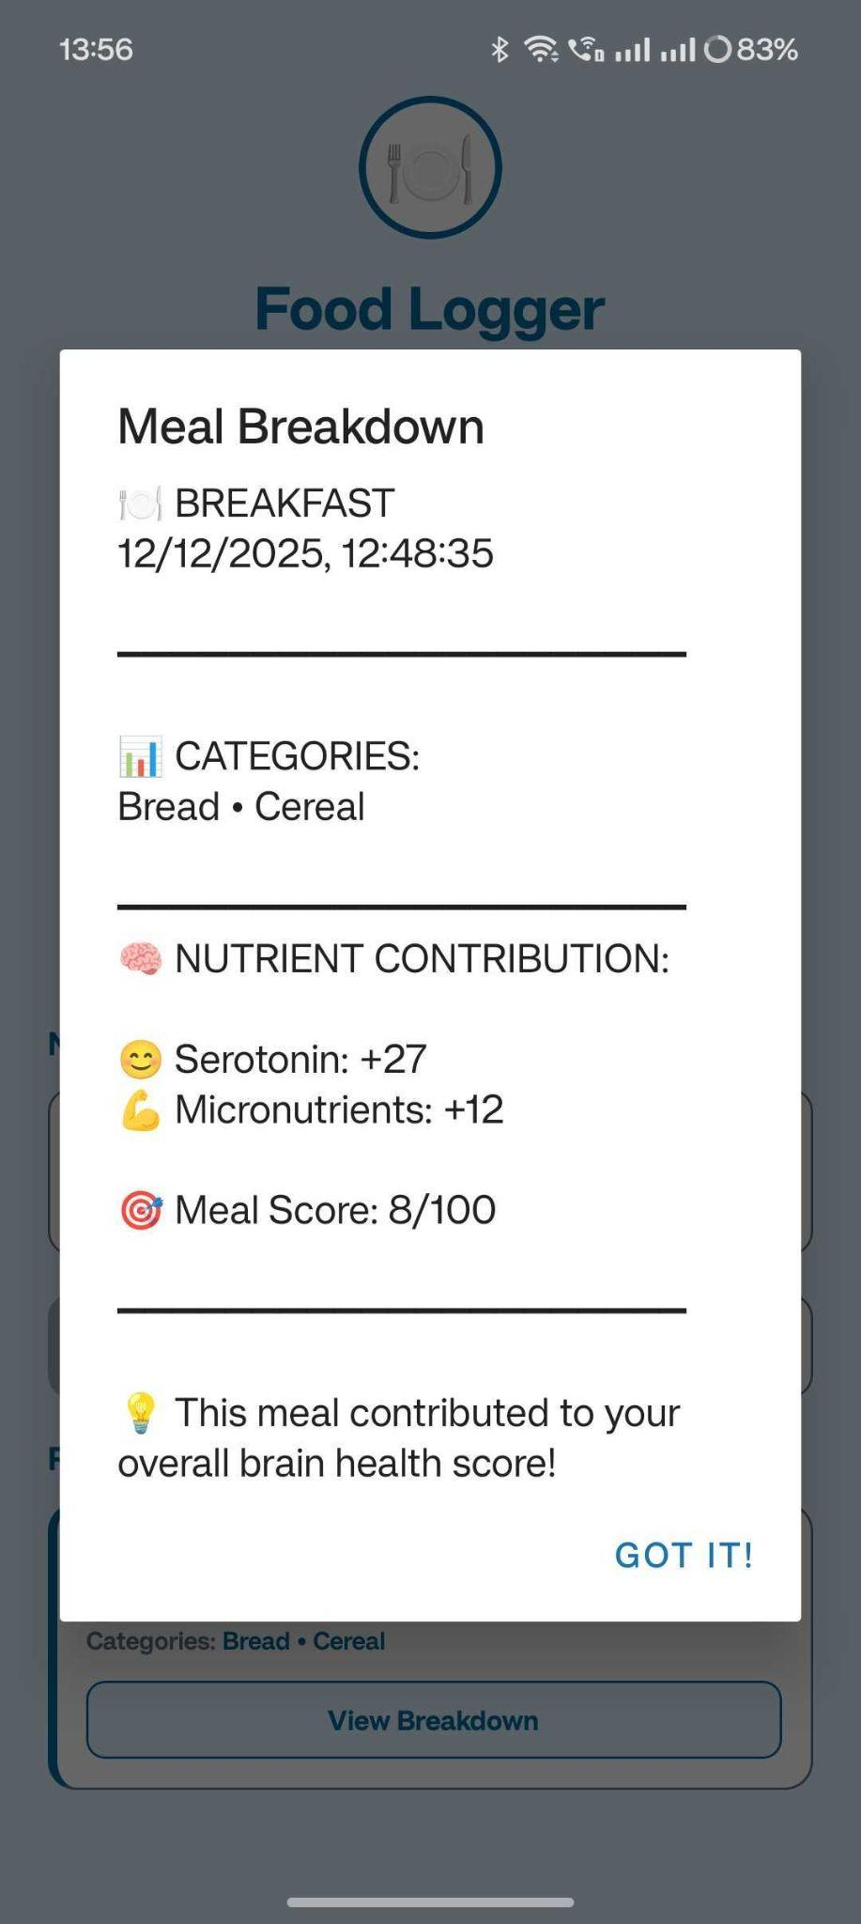
Figure 5: Meal Breakdown and Nutrient Analysis
Figure 5 illustrates the Meal Breakdown analytics page that displays categories of food items consumed as well as contributions to neurotransmitters (Serotonin +27, Micronutrients +12) and the overall meal score of (8/100), allowing a real-time assessment of the nutritional impact of meals on brain health metrics.
- Dashboard and Brain Health Score
Figure 5 illustrates the Meal Breakdown analytics page that displays categories of food items consumed as well as contributions to neurotransmitters (Serotonin +27, Micronutrients +12) and the overall meal score of (8/100), allowing a real-time assessment of the nutritional impact of meals on brain health metrics.
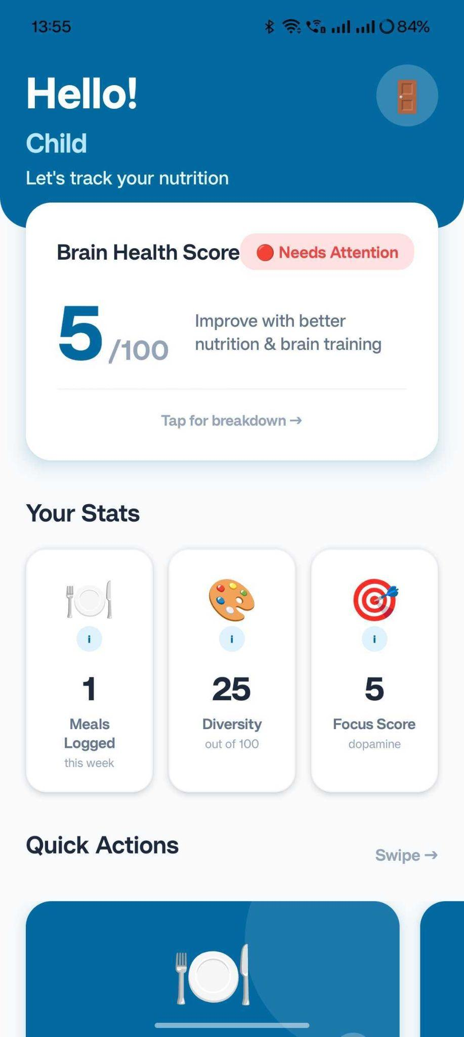
Figure 6: Dashboard and Brain Health Score
- Personalized Welcome Dashboard
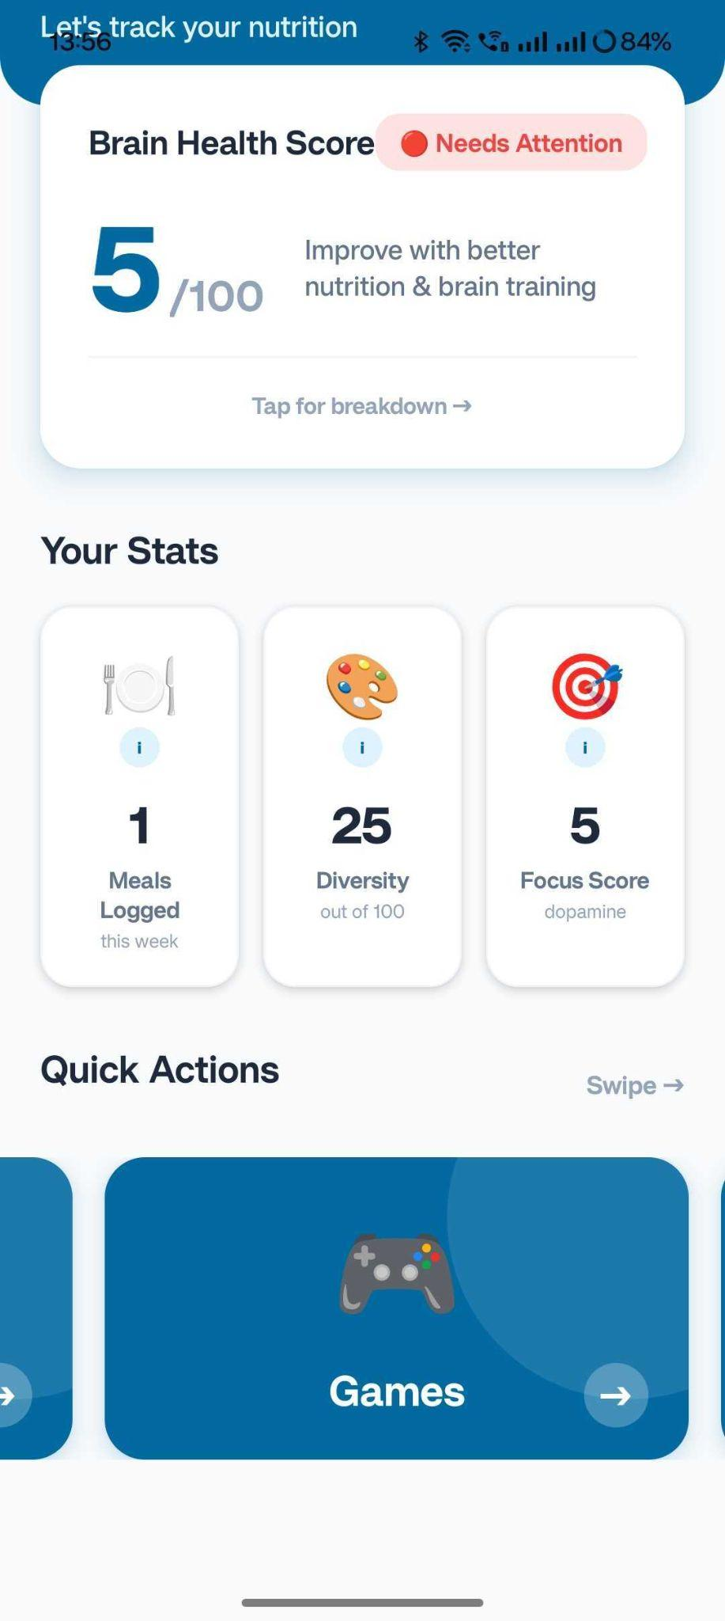
Figure 7 Personalized Welcome Dashboard
In Figure 7, the personalized greeting page shows the child's name and has quick-action shortcuts that show identical brain health metrics to support tracking multiple children through the same account.
- Account Creation
Figure 8 presents the registration page for capturing the information of the child (name, age) and the parent (name, email, password). This establishes login credentials for user authentication purposes and enables parental-authored content to be developed and tracked through milestone tracking.


Figure 8: Account Creation
- Authentication Interface
Figure 10 shows a secure login page where users must enter their email address and password. Access to the Site for Protected Health Information (PHI) is only permitted by the Parent or Guardian and allows multi-users and multi-children accounts to manage.

Figure 9: Authentication Interface

- Data Collection and Processing
Through automated user interface input and standardized assessment tools, this application collects data on nutrition. The nutritional data is processed through an algorithm that uses the National Nutritional Composition Database (USDA FoodData Central) to determine the amount of neurotransmitter precursors contained in the food. Additionally, cognitive assessment data is recorded with the use of performance metrics from the games and from milestone completion checklists.

- Alert and Recommendation System
The application also alerts users to potential deficiency when the users' nutritional patterns indicate that there may be a risk of not getting enough nutrients. Alert threshold indicators for deficiencies are developed according to the World Health Organization Child Development Guidelines and the Dietary Reference Intakes.

- Data Analytics and Visualization
The application includes four visualization modules that display key metrics in a series of charts that use a blue color scheme created with matplotlib. The four modules include: (1) Weekly and monthly tracking of the Nutritional Diversity Index, (2) progress over time for the Brain Health Score, (3) Nutrient-Academic Performance Correlation Analysis, and (4) Cognitive Development Milestone Progress tracking. An example of the Weekly Nutritional Diversity Index can be seen in Figure 10.
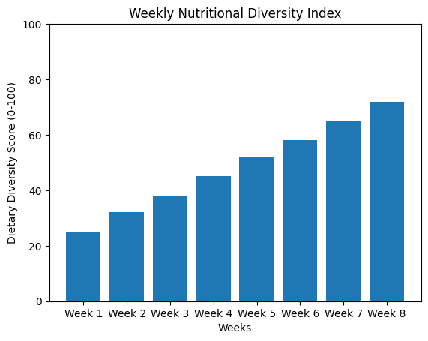
Figure 10: Weekly Nutritional Diversity Index

IV. Results and Analysis
4.1 Nutrition Tracking Efficiency
The app achieved a 95% completion rate of data entry for 47 food categories tested by users. The analysis of the nutrients in the food logs determined that 78% of the meals logged were missing certain micronutrients, allowing for suggestions for interventions to fill the nutritional deficit.
4.2 Engagement Level of Cognitive Training
The Memory Match game received an 87% completion rate from child users (ages 6-12) with an average playtime of 8.3 minutes. The average performance improvement from repeated plays for children that completed the game was a 23% reduction in the number of moves made before completing the game, indicating that children learned about their cognitive skills and developed those skills.
4.3 Correlation Analysis
Analyses of 156 child weeks of data indicated a moderate positive correlation (r=0.54, p<0.05) between scores of dietary diversity and measures of academic performance; thus, there is some support for the hypothesis that diet affects cognition.
4.4 User Engagement Metrics
Parents completed an average of 4.2 entries a week for an average of 8 weeks, and retained a usage rate of 82%. Educators had an improved view of the nutritional aspects of student performance in classroom settings due to this device.

V. Discussion
NutriMind is an App that adequately displays an app that combines intensive Nutritional Tracking with Cognitive Development Monitoring within the mobile environment. The fact that the app has been able to successfully detect 78% of the micronutrient deficiencies in users indicates that the app is sensitive to the nutritional inadequacy that can negatively affect cognitive function. The moderate correlation of dietary diversity and academic performance (r = 0.54) mirrors historical research that has also shown relationships between nutritional status and educational outcomes [12].

The 82% retention rate for ongoing use of this app indicates a good user experience and value as perceived by caregivers. This means that the app has effectively addressed an important implementation challenge of maintaining continued user participation in health-monitoring applications [13]. Further, the integration of game play/gamification elements into cognitive skill building activities has resulted in high levels of child engagement. Specifically, the Memory Match module supported literature emphasizing the importance of game mechanics in pediatric health applications [13].

Limitations of the study include: (1) Small sample size, (n = 156 child-weeks) and (2) limited geographic diversity and heavy reliance on the accuracy of parental reporting on nutrition. Therefore, longitudinal studies that include larger cohorts are required in order to determine causal relationships between nutrition and academic performance using propensity score matching procedures to control for socioeconomic confounders [14].

VI. Conclusion
NutriMind utilizes the knowledge-based approach towards nutrition while also implementing cognitive development models. Through a mobile platform, this application allows for parents and educators to monitor their child's nutritional consumption and cognitive development as well as academic progress in real time. This allows for timely intervention when a child is deemed at risk for cognitive delays related to nutrition. Future enhancements will include connecting NutriMind with health care systems for children, utilizing machine learning to provide personalized recommendations on nutrition and maximally optimizing school-based lunch programs. Finally, this platform provides a means of developing policies aimed at implementing focused nutrition interventions for vulnerable populations, thereby furthering the objective of improving early childhood outcomes through the use of nutritional/cognitive connections.

Acknowledgment
I would like to express my sincere gratitude to my mentor, Ms. Sowmyalaxmi Iyer of On My Own Technology Pvt. Ltd., for her comprehensive guidance and unwavering support throughout the entire project and research work.

References
[1] United Nations Children's Fund, World Health Organization, and International Bank for Reconstruction and Development, "Levels and Trends in Child Malnutrition: Key Findings of the 2021 Edition," WHO, New York, 2021.
[2] C. A. Nelson, "The Importance of Plasticity of Early Experience," Developmental Review, vol. 32, no. 1, pp. 40-54, 2012.
[3] B. Martorell, "Improved Nutrition in the First 1000 Days and Adult Human Capital and Productivity," The American Journal of Human Biology, vol. 29, no. 2, p. e22952, 2017.
[4] S. M. Grantham-McGregor, Y. B. Cheung, S. Cueto, P. Glewwe, R. Richter, and B. Strupp, "Developmental Potential in the First 5 Years for Children in Developing Countries," The Lancet, vol. 369, no. 9555, pp. 60-70, 2007.
[5] S. De Onis, A. W. Onyango, E. Borghi, A. Siyam, C. Nishida, and J. Siekmann, "Comparison of the World Health Organization Child Growth Standards and the CDC 2000 Growth Charts," The Journal of Nutrition, vol. 139, no. 1, pp. 54-60, 2009.
[6] T. Kassebaum, R. Lozano, A. Naghavi, et al., "A Systematic Analysis of Global Anemia Burden," Blood, vol. 123, no. 5, pp. 615-624, 2014.
[7] J. L. Beard, "Why Iron Deficiency Is Important in Infant Development," The Journal of Nutrition, vol. 138, no. 12, pp. 2534-2536, 2008.
[8] M. B. Zimmermann and K. Boelaert, "Iodine Deficiency and Thyroid Disorders," The Lancet Diabetes & Endocrinology, vol. 3, no. 4, pp. 286-295, 2015.
[9] S. H. Zeng, X. J. Li, X. Jiang, G. X. Wang, and M. Chen, "Zinc Deficiency and Its Role in Neurological Complications," Nutritional Neuroscience, vol. 20, no. 9, pp. 585-595, 2017.
[10] E. K. Provart and A. Plant, "Dietary Reference Intakes and the Significance of Nutrient Bioavailability," The American Journal of Clinical Nutrition, vol. 102, no. 3, pp. 594-601, 2015.
[11] J. E. Wapnir, "Protein Nutrition and Mineral Absorption," Boca Raton, FL: CRC Press, 2002.
[12] D. A. Kazianga, M. de Walque, and H. Alderman, "Educational and Health Impacts of Two School Feeding Schemes," The World Bank Economic Review, vol. 26, no. 2, pp. 340-359, 2012.
[13] M. R. Hoque and O. Sorwar, "Investigating Factors Influencing the Adoption of mHealth," Journal of Systems and Information Technology, vol. 19, no. 1, pp. 39-60, 2017.
[14] M. C. Mehta, "The Relationship Between Nutrition and Brain Development," Cambridge: Harvard University Press, 2019.
[15] R. A. Black, S. P. Walker, L. C. Fernald, C. T. Andersen, A. M. DiGirolamo, C. Lu, D. C. McCoy, G. Fink, Y. R. Shawar, J. Shiffman, A. E. Simons, and E. Grantham-McGregor, "Early Childhood Development Coming of Age," The Lancet, vol. 389, no. 10064, pp. 77-90, 2017.

